**Grove - Vibration Motor**

窗体顶端

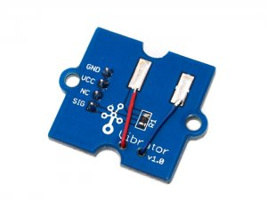

http://www.seeedstudio.com/depot/includes/templates/pure_green/images/next_l.gif

* [http://www.seeedstudio.com/depot/bmz_cache/4/4a36391249f73108f45a5e73ffa7957d.image.55x41.jpg](http://www.seeedstudio.com/depot/images/product/gvib.jpg)
* [http://www.seeedstudio.com/depot/bmz_cache/0/063d200c985ddd1e5cfa2c5f49a01732.image.55x41.jpg](http://www.seeedstudio.com/depot/images/product/gvib_01.jpg)

http://www.seeedstudio.com/depot/includes/templates/pure_green/images/next_r.gif

* **Price:**

$2.99  [(Price Feedback)](javascript:void())

* **SKU:**

ROB51043P

* **Weight:**

5Gram

* **Units in Stock**

18

* **Designed by:**

[Seeed Studio](http://www.seeedstudio.com/)



[Other products from designer](http://www.seeedstudio.com/depot/seeed-studio-m-23.html)

* **Quantity:** Max: 18  
  
* [Add to Wish List](http://www.seeedstudio.com/depot/index.php?main_page=un_wishlist&products_id=839&cPath=170_171&action=un_add_wishlist)

Description

It is consist one coin type motor which is a Permanent Magnet coreless DC motor. It vibrates when the input is logic HIGH. It is very easy to drive and Grove compatible. Can be used in toys and cell phone modules.

**Documents**

Please visit our[wiki page](http://garden.seeedstudio.com/index.php?title=Twig_-_Vibrator)for more info about this product. It will be appreciated if  you can help us improve the documents, add more demo code or tutorials. For technical support, please post your questions to our [forum](http://www.seeedstudio.com/forum).

窗体底端